Project Design Phase-II
Data Flow Diagram & User Stories

Date | 30 June 2025
Team ID | LTVIP2026TMIDS24294
Project Name | BOOKNEST-WHERE STORIES NESTLE
Maximum Marks | 4 Marks

Data Flow Diagrams:
A Data Flow Diagram (DFD) is a traditional visual representation of the information flows within a system. A neat and clear DFD can depict the right amount of the system requirement graphically. It shows how data enters and leaves the system, what changes the information, and where data is stored.

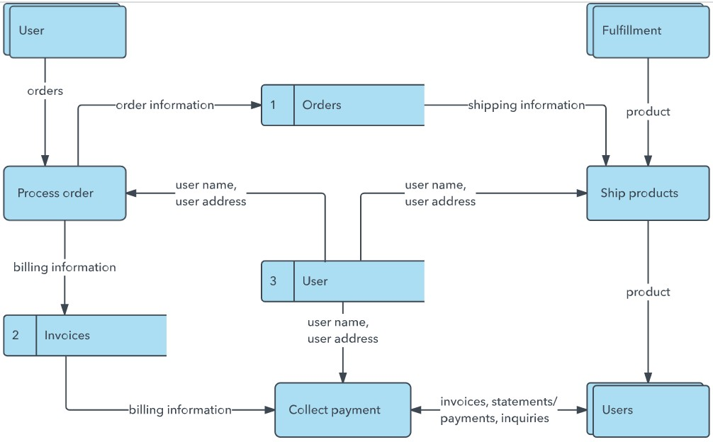
Example: (Simplified)
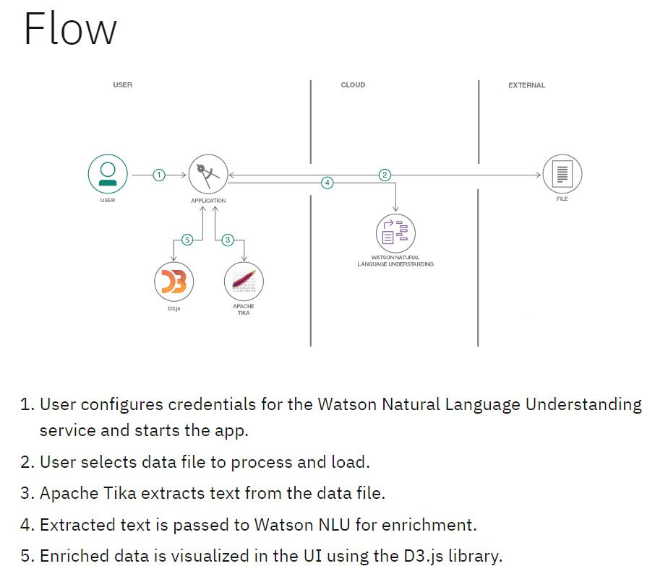

User Stories
Use the below template to list all the user stories for the product.
User Type | Functional  Requirement  (Epic) | User Story  Number | User Story / Task | Acceptance criteria | Priority | Release
Customer  (Mobile user) | Registration | USN-1 | As a user, I can register for the application by entering my email, password, and confirming my password. | I can access my account / dashboard | High | Sprint-1
Customer (Mobile user) | Registration | USN-2 | As a user, I will receive confirmation email once I have registered for the application | I can receive confirmation email & click confirm | High | Sprint-1
Customer (Mobile user) | Registration (Facebook) | USN-3 | As a user, I can register for the application through Facebook | I can register & access the dashboard with Facebook Login | Low | Sprint-2
Customer (Mobile user) | Registration (Gmail) | USN-4 | As a user, I can register for the application through Gmail | I can register & access dashboard via Gmail login | Medium | Sprint-1
Customer (Mobile user) | Login | USN-5 | As a user, I can log into the application by entering email & password | I can securely access my dashboard after login | High | Sprint-1
Customer (Mobile user) | Dashboard | USN-6 | As a user, I can view books, orders, and suggestions | Dashboard shows books, orders, and personalized recommendations | High
  Sprint-2
Customer (Web user) | Registration/Login | USN-7 | As a web user, I can register and log in just like mobile users | Same flow works on web without issues | High
  Sprint-2
Customer Care Executive | Orders | USN-8 | As a web user, I can place orders for available books | Orders are placed and confirmed with status | High
  Sprint-3
Administrator | Support | USN-9 | As support staff, I can view and respond to user queries | Help tickets are visible and respond able by staff | Medium
  Sprint-4
Administrator | Admin Dashboard | USN-10 | As an admin, I can view users, books, and generate reports | Admin sees all key data in a single dashboard | High
  Sprint-2
Customer (Mobile user) | Reports | USN-11 | As an admin, I can export daily/monthly platform reports | Reports generate correctly in CSV/PDF formats | Medium
  Sprint-4
Customer (Mobile user) | Feedback | USN-12 | As a user, I can submit feedback on the book or seller | Feedback form submits & appears to seller or admin | Medium
  Sprint-2

